Recommendations

To make better Promotional Strategies, we need to analyze the effectiveness of different promotion periods and types to optimize future campaigns. Expanding our investigation beyond four promotion periods would enhance our ability to make accurate predictions for upcoming campaigns.
We lack information on environmental effects. Therefore, considering the inclusion of additional data such as customer data, economic indicators, and competitor promotions could improve the accuracy of our model.

Additional Data Sets

To improve the model and gain deeper insights, the following additional data sets could be useful:
Promotions Data: Discount rates, number of advertisements.
Seasonal Trends: Information on seasonal sales trends.
Important Dates: Holidays, payment dates, etc.
Customer Data: Information on customer age, gender, income level, etc.
Economic Indicators: Data on inflation rates, unemployment rates, etc.
Competitor Promotions: Data on promotions run by competitors.
These data sets can be obtained through market research firms, government databases, and customer surveys.

The client aims to understand the impact of promotions on product sales across various stores. Specifically, the goal is to measure the effectiveness of promotional campaigns and identify how different products and stores react to these promotions.
Part 0: Imports and Data Preparation
This part consists of data loading, cleaning, handling missing values, creating features from date attributes, and identifying promotion periods.

I have included all the code where I tried to understand the data, which shows the reasons behind my decisions regarding model selection, feature engineering, and other parts.

Part 1: Exploratory Data Analysis
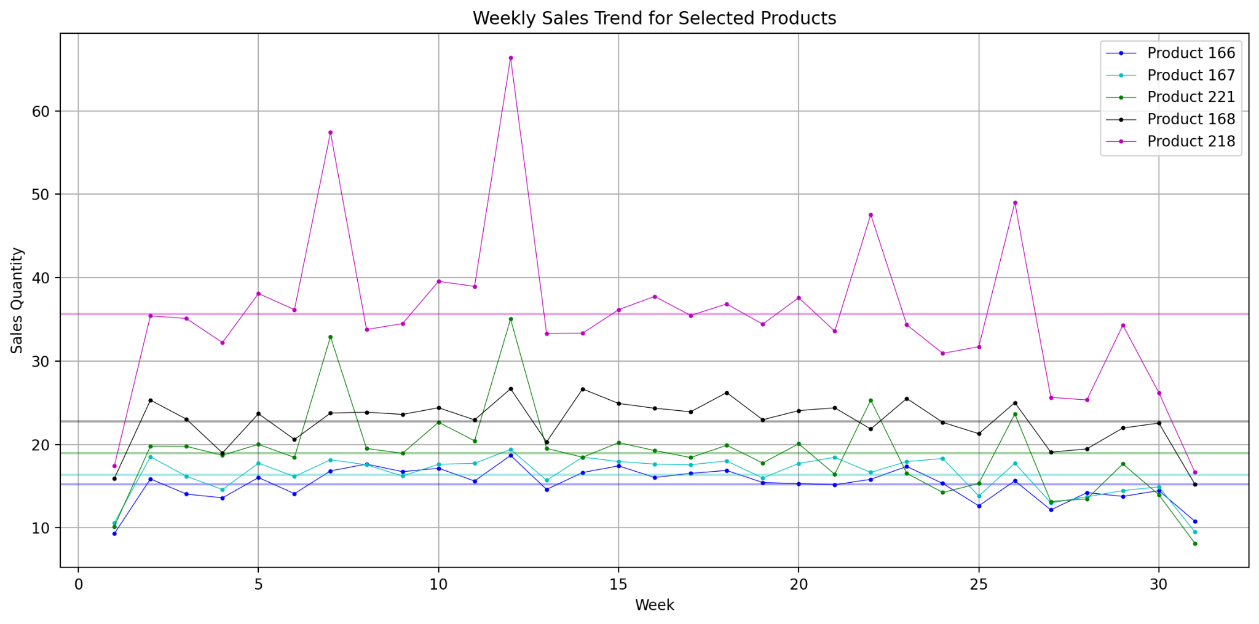
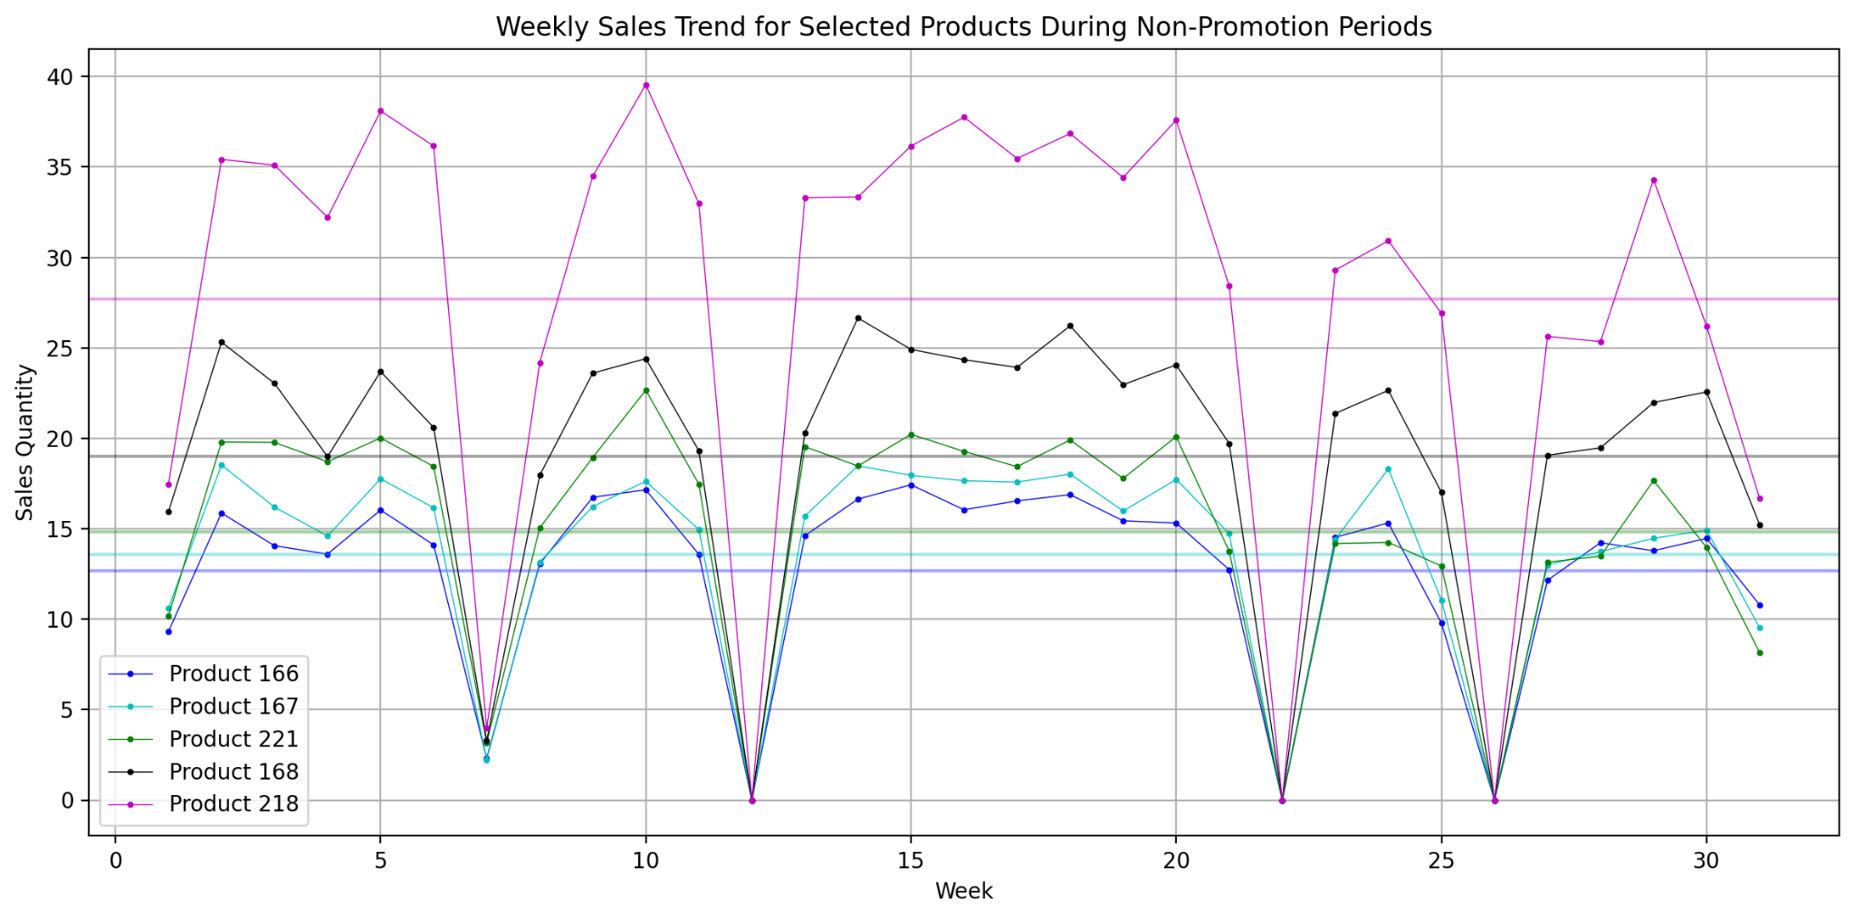
I am investigating the relationship between products and sales quantities, as well as between stores and sales quantities. I have illustrated the weekly sales changes for both stores and products during both promotions and non promotions periods:
We have charts displaying all products and all stores sorted by their weekly sales rates:
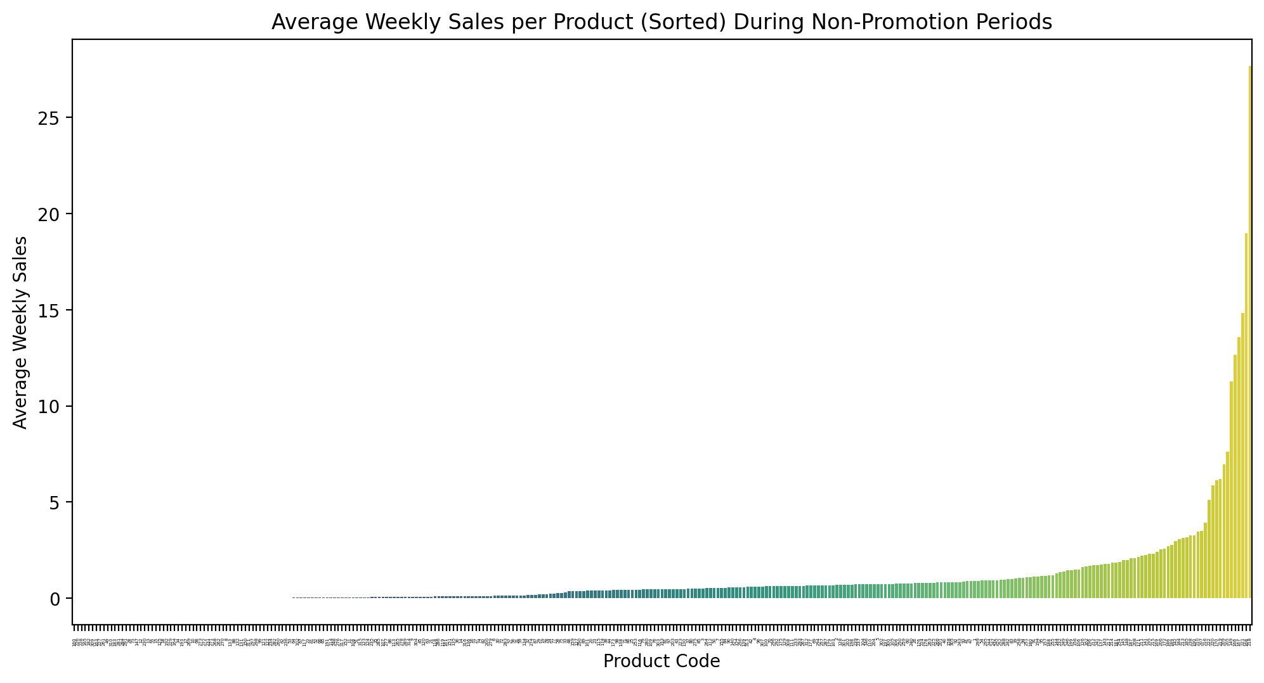

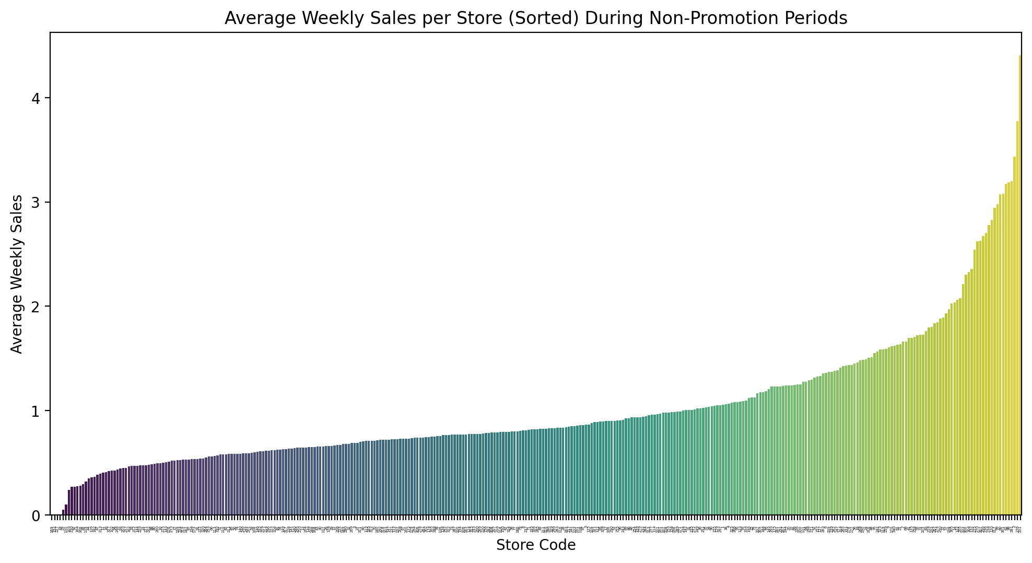

Additionally, this section includes data preparation for the next step, which involves clustering the stores and products based on their average weekly sales.
Part 2: Classification for Products & Stores
As observed in Part 1, certain products can be distinguished from others based on their average weekly sales rates. Therefore, we aim to cluster these products into three distinct groups. To achieve this, I have employed various approaches and methodologies. We will apply the same clustering techniques to the stores, grouping them based on their weekly sales rates to uncover meaningful patterns and insights.
Percentile-Based Classification:
This approach ensures a balanced classification into three groups which would enable us to see if there is a significant difference between the promotion impacts of the different categories in products and stores easier. Also, this approach avoids arbitrary thresholds and takes the distribution of sales into account.
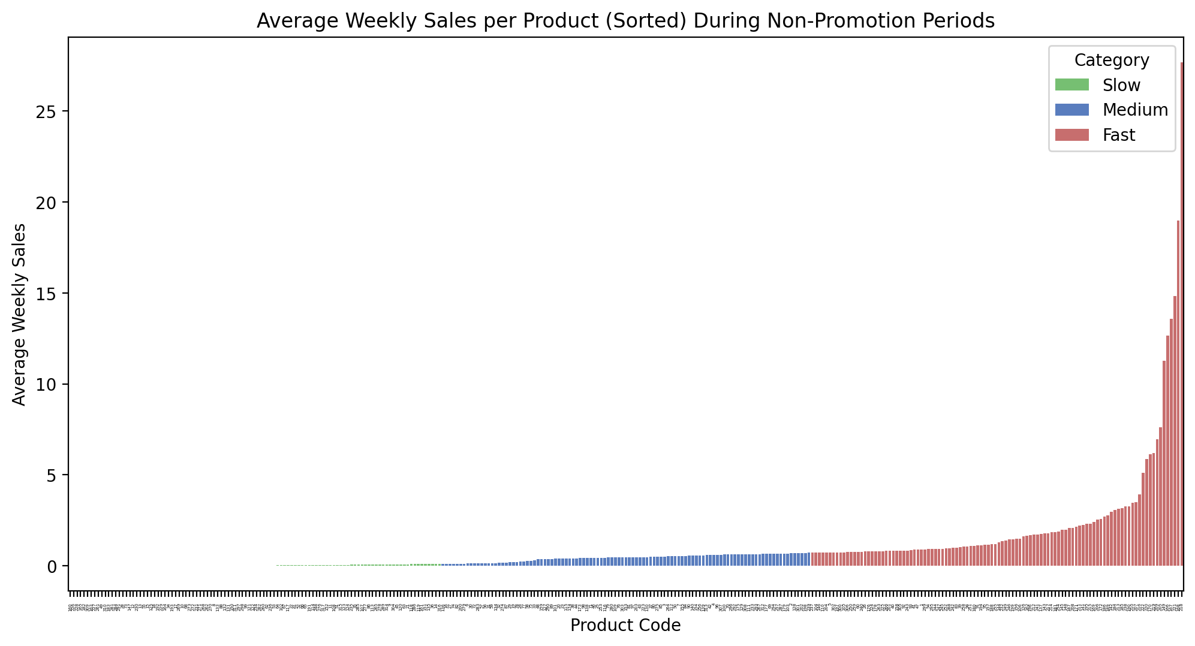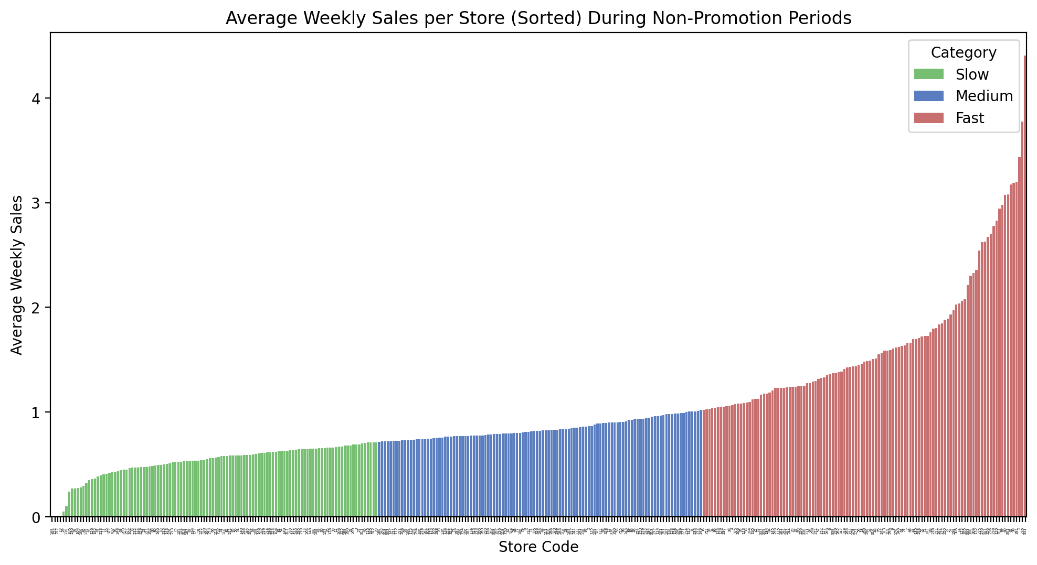
K-Means Clustering:
K-means clustering identifies natural groupings in the data, ensuring that products and stores within each cluster have similar sales behaviors. This leads to more accurate and meaningful classification which would enable us to do better decision-making and predictions.
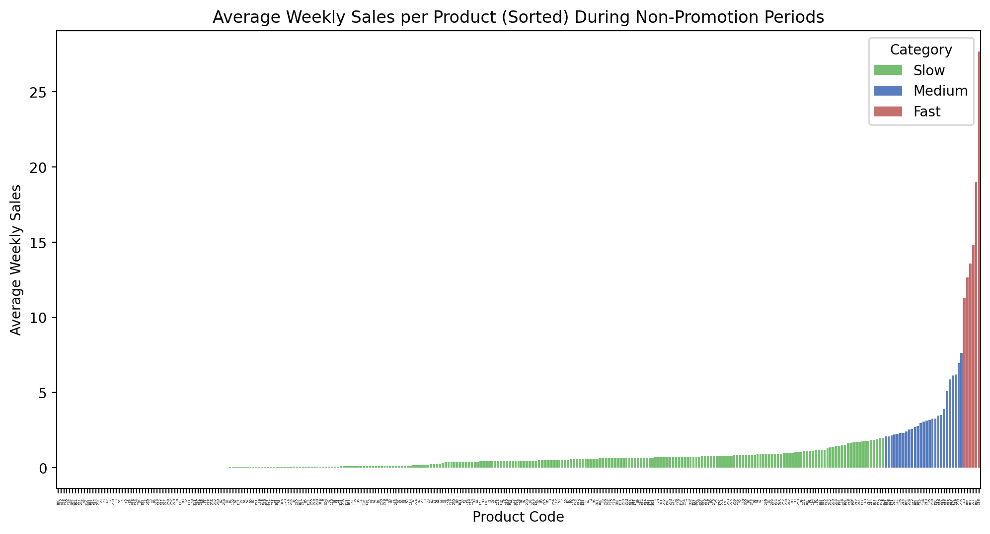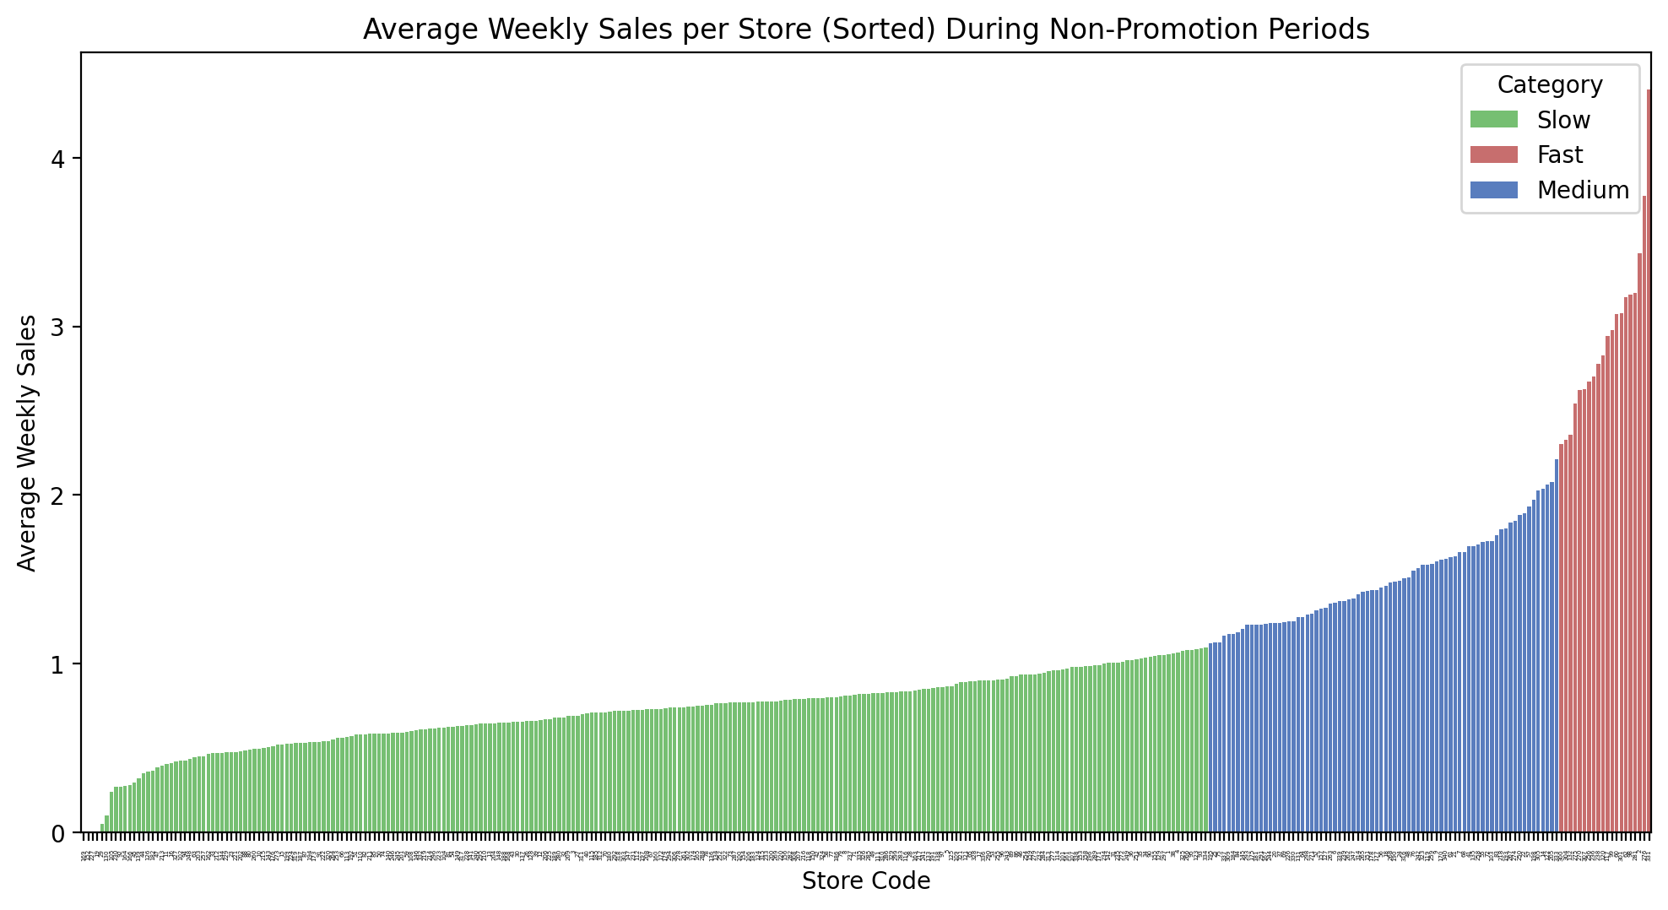

Part 3: Effects of Promotions
I have listed the top 10 products and stores with the biggest sales increase and created the bar chart illustrating sales increase after promotion for each product with its category across all stores in ascending order below.
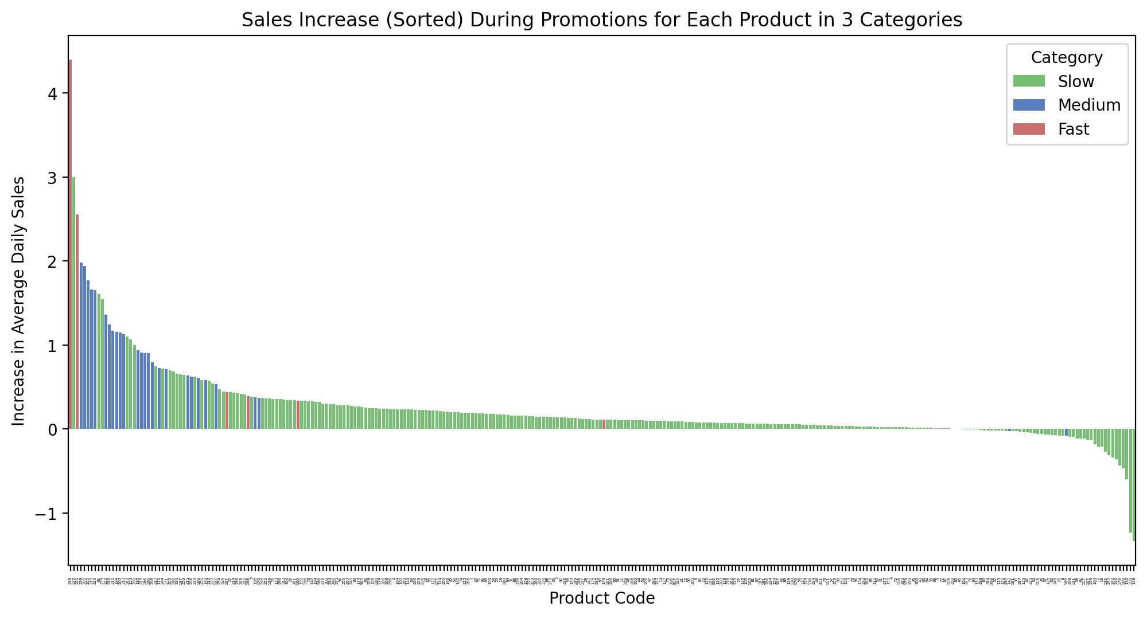
The bar chart illustrates sales increase after promotion for each store with its category across all products in ascending order below. 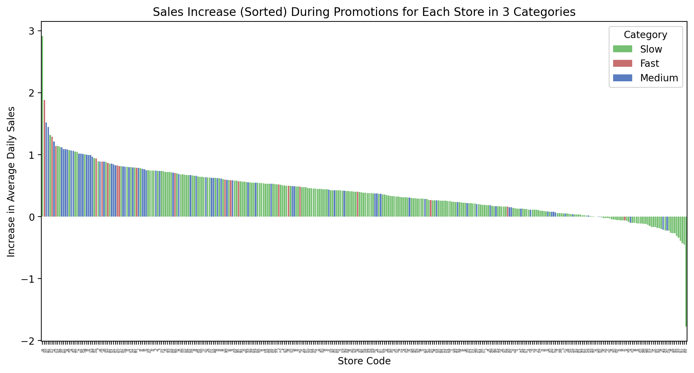I have done a t-test is an inferential statistic used to determine if there is a statistically significant difference between the means of promotion impacts of the Fast versus Slow in items and stores.
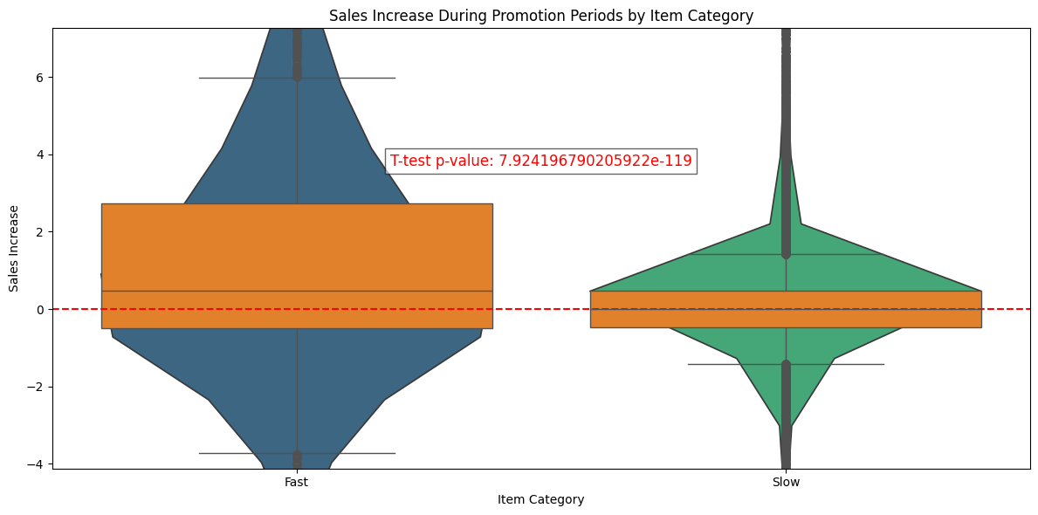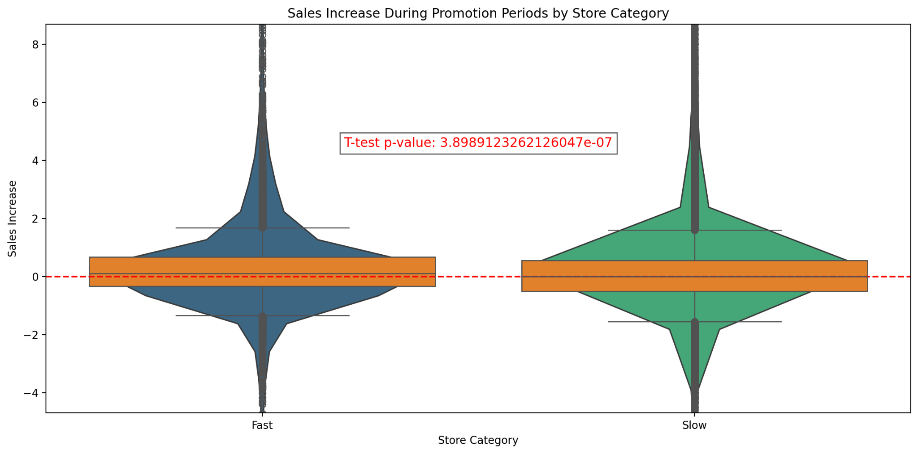
Considering the two results above (see the code), it is safe to reject the null hypothesis that there is no difference between means. There is a significant difference between the promotion impacts of fast and slow stores. Also, there is a significant difference between the promotion impacts of fast and slow products.

Part 4: Model Creation
I've attempted to investigate which features could enhance the model's performance and sought answers regarding factors influencing sales changes during promotions:
- Promotion Duration (typically spans 7 days.)
- Promotion Period (Each promotion occurs in a different month, correlating with seasonal and monthly variations.)
- The day of the week could also influence sales.
- Product and store categories might play significant roles.
- There's also a daily increase rate whose causes remain unknown.
Based on the available data, our analysis begins with an examination of store and product types. We'll employ regression modeling to quantify their impacts on sales during promotional periods. However, interpreting the effects of promotion timing and duration on sales is challenging due to data limitations.
(After doing a quick model deployment, the model turned out to be bad so I’ve added more features and changed my linear regression model to a decision tree regression model .)
For each categorical feature, I converted them to dummy variables.
"DailySalesIncrease" is computed by subtracting yesterday's sales quantity from today's sales quantity.
The "IsPromotion" feature indicates whether a date falls within a promotional period. In our analysis, we assume uniformity across all promotions since we haven't included any distinguishing factors to identify specific promotions.
I have trained my models with these features to predict sales quantity.
- DailySalesIncrease
- IsPromotion
- ProductCategory_Fast
- ProductCategory_Medium
- ProductCategory_Slow
- StoreCategory_Fast
- StoreCategory_Medium
- StoreCategory_Slow
- DayOfWeek_1
- DayOfWeek_2
- …
- DayOfWeek_6

I have added the importance of the features for the both model.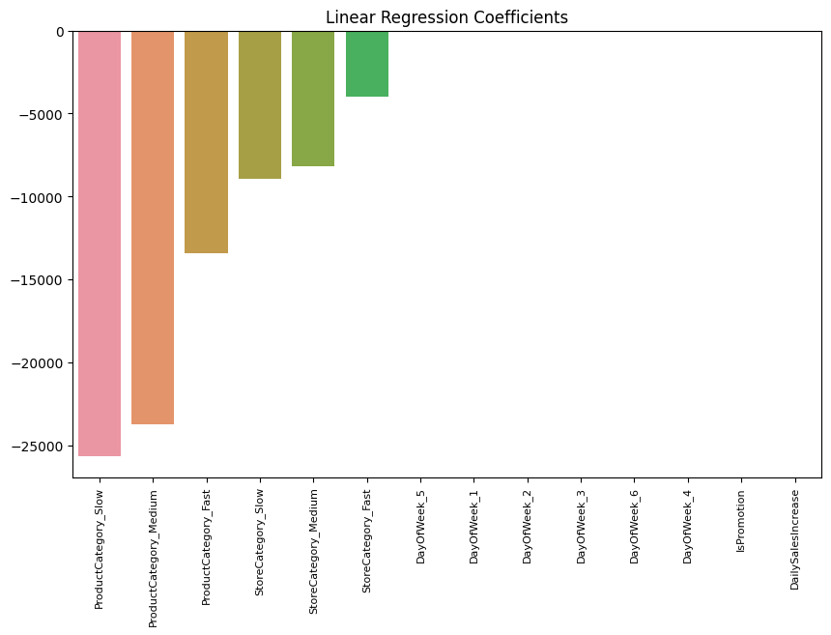
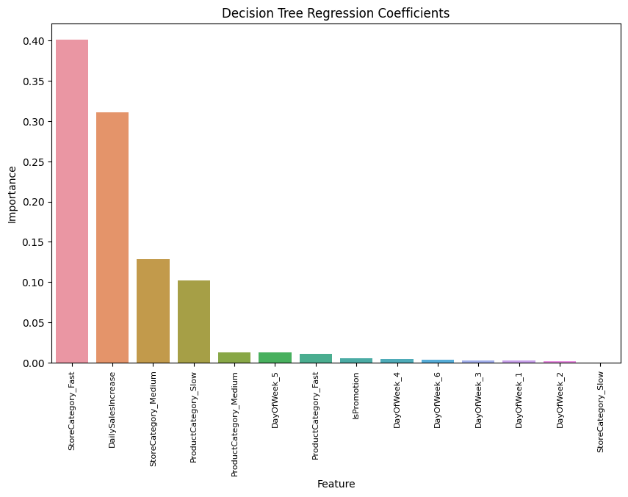
Part 5: Model Evaluation
I used the data from promotion period 5 as test data and obtained the following results. Initially, I visualized the difference between actual and predicted sales, finding that most results converged to 0, thereby making the MSE error acceptable. However, apparently the features I prepared do not sufficiently explain the sales quantity with the available data.
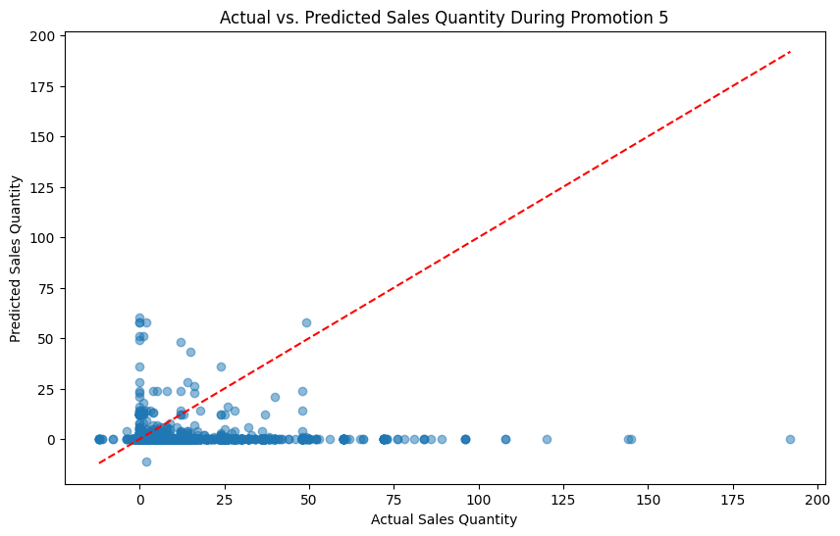
MSE measures the average of the squares of the errors—that is, the average squared difference between the estimated values and the actual value.
mean_squared_error(y_promotion5_test, y_promotion5_pred) -> 2.754178264365683
R² provides an indication of goodness of fit and therefore a measure of how well unseen samples are likely to be predicted by the model.
r2_score(y_promotion5_test, y_promotion5_pred) - > -0.01999031527023320
For both models, I didn’t get good R-squared results which means that the variance in sales increases cannot be explained by the model. There must be other features affecting the sales increase.
https://drive.google.com/file/d/1mYmLVJ0RFfxk1HvcaQOq4If_YXPIhyhm/view?usp=sharing

